Chapter 9 Homework Problems

Problem 9.1

A car with a mass of 1100 kg traveling at 50 km/hr locks up its brakes, stopping over a distance of 18 meters. If the same car were to lock up its brakes when traveling 80 km/hr how far would you expect the car to slide before coming to a stop? (Hint: assume the same friction force in both cases)

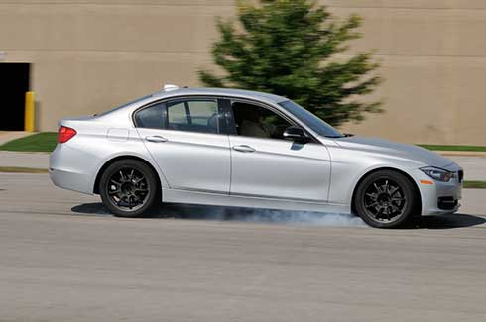

(Solution: d = 46.06 m)

Problem 9.2

A 2500 lb car traveling 60 mph (88 ft/s) impacts a highway crash barrier as shown below. If the barrier were designed to exert the following force over the 40 ft distance of the barrier, how far would you expect the car to travel after impacting the barrier?

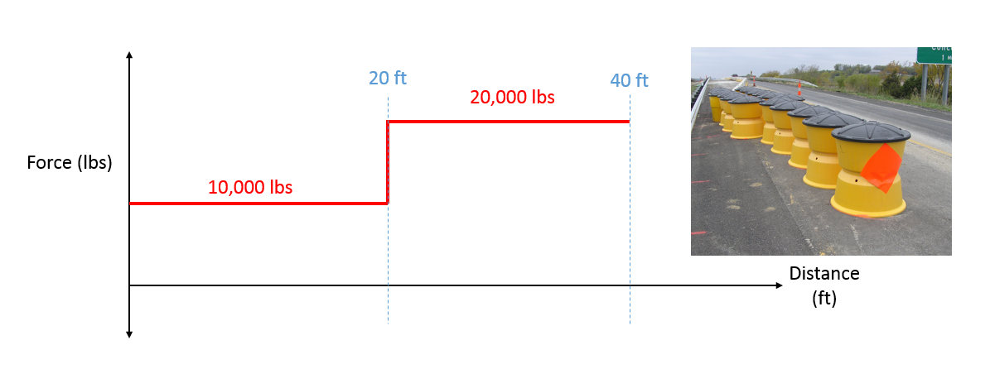

(Solution: without holes: $d=25.03 ft$)

Problem 9.3

The Duquesne Incline transports passengers up a 30.5 degree slope. If a fully loaded car has a mass of 5500 kg, what power is required to maintain an uphill speed of 10 km/hr?

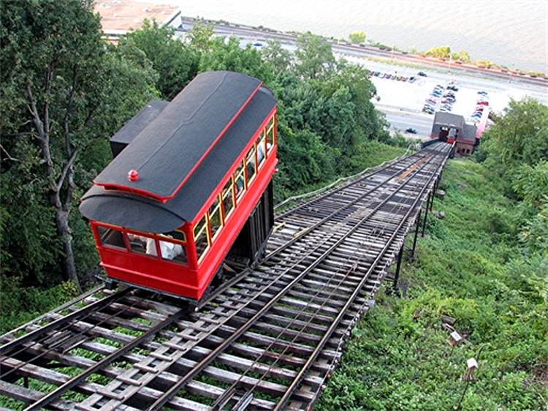

(Solution: P = 76.13 kW)

Problem 9.4

A bungee jumper with a weight of 150 lbs uses a bungee with an unstretched length of 60 ft.

1. Assuming no air resistance, what will the jumper’s velocity be just before the bungee starts to stretch?
2. If the bungee jumper falls a maximum distance of 150 ft, what is the spring constant of the bungee?

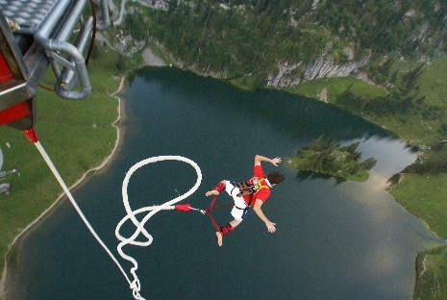

(Solution: v = 62.16 ft/s, k = 5.55 lbs/ft)

Problem 9.5

An 1100 kg truck is being used to raise a 100 kg box using the setup shown below. When the box is at a height of 3m, the box has a velocity of 1 m/s.

1. How far did the truck travel to lift the box this high? (This is a dependent motion problem)
2. What is the velocity of the truck at this time?
3. What was the average force the truck exerted on the ground over this period?

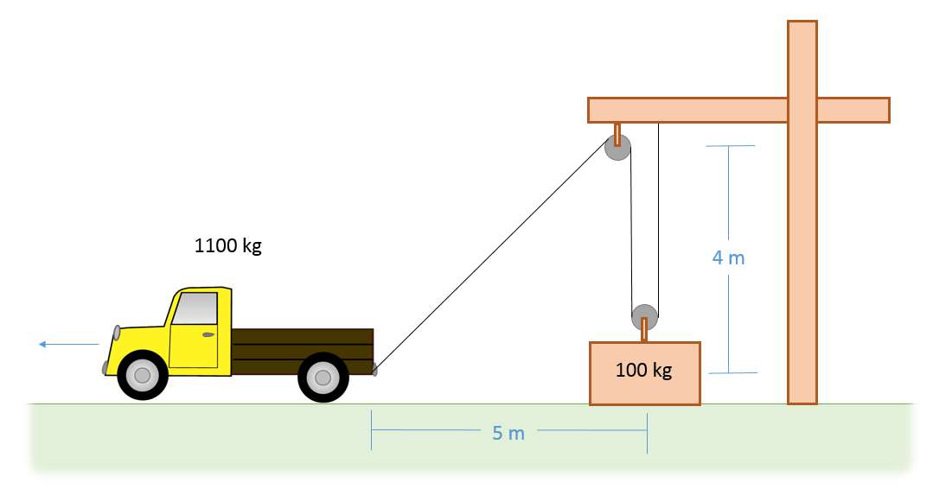

(Solution: distance traveled = 6.7 m, truck speed = 2.12 m/s, average force on ground = 815.7 N)

Problem 10.6

An impact-testing device consists of 20 kg box supported by two 5 kg slender rods. The two rods are set up in parallel so that the box remains level as it swings. If the whole system is released in the upright position shown below, what is the velocity of the box after traveling 90o?

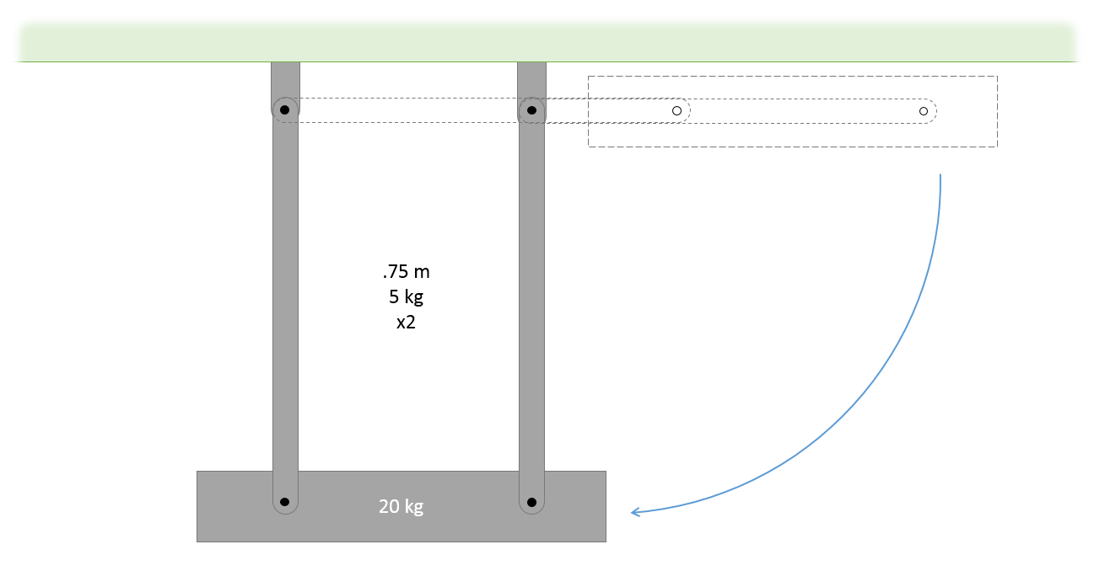

(Solution: v = 3.97 m/s)

Problem 10.7

A 40 lb door with a width of 36 inches has a spring with an unstretched length of 4 in designed to close the door when left open. The spring is anchored as shown below when closed (solid outline is closed, dotted outline is open 90o). If we want the door to have an angular velocity of .2 rad/s upon closing when released from rest at 90o, what should the spring constant of the spring be? (This is the top view of the door below)

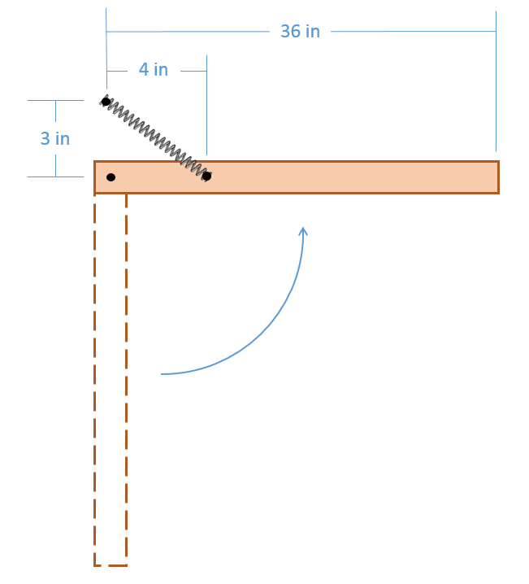

(Solution: k = 2.68 lbs/ft =.224 lbs/in)